**BIS 305**

# Assignment 1

**Due 9/12/22**

Assignment to be turned in. This assignment should be well written with a word processor.

**Problems 5 and 6 on page 30 of the text.**

5. A firm installs 1,500 air conditioners that need to be checked every six months. The firm can hire a team from its logistics department at a fixed cost of €6,000. This team will check each unit for €15.00. The firm can also outsource this at a cost of €17.00 inclusive of all charges.

1. For the given number of units, compute the firm’s total cost of checking for both options. Which is a better decision?

$6,000 + $15($1,500) = $28,500

$17($1,500) = $25,500

The better decision is outsourcing at an inclusive cost of $17 per air conditioner unit.

1. Find the break-even volume and characterize the range of volumes for which it is more economical to outsource.

The break-even volume comes at 3000 checked ac units.

**Math:**

**$17(outsource) - $15(logistic department) = $2 variable cost**

**6000/2 = units for Break even**

**3000 = units for Break even**

**$6000 + $15(3000) = $51000**

**$17(3000) = $51000**

Between 0-3000 units, it’s better to go with the outsourcing option.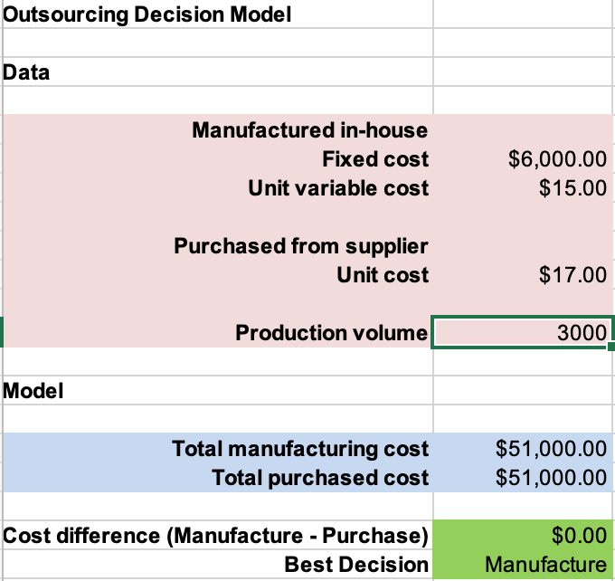

6. Use the model developed in Example 1.5 to predict the total sales for weeks 2 through 16 and compare the results to the observed sales. Does the accuracy of the model seem to be different when coupons are used or not? When is advertising used or not?

**RAW DATA**

This is the Raw data table. The Accuracy of this table is awful. The formula I used to get accuracy was: Total Sales – Predicted Sales / Total sales. Ignoring the Accuracy, I can see that the biggest underestimate from the predicted sales was -$122.98 and the biggest overestimate was $86.04. This results in a range of $209.02. Looking at the sum of total sales (week 1-16) vs predicted sales there was a difference in -$1.40, which looks like the model preformed good.

**Advertising VS No Adverting**

This is the table with only advertising. The biggest underestimate from the predicted sales was -$122.98, The biggest overestimate was $86.04. This results in a range of $209.02. Looking at the sum of total sales vs predicted sales there is a difference of -$1.22.Application, table
This is the table without advertising. The biggest underestimate from the predicted sales was -$75.96, the biggest overestimate was $69.84. This resulted in a range of $145.80. Looking at the sum of total sales vs predicted sales there was a difference of -$0.20.

**The model with no advertising had a smaller overall difference in the total sum difference compared to having advertising ($1.02).**

**Coupon VS No Coupon**

This is the table with no coupons. The biggest underestimate from the predicted sales was -$122.98, The biggest overestimate was $86.04. This results in a range of $209.02. Looking at the sum of total sales vs predicted sales there is a difference of -$0.70.

This is the table with coupons. The biggest underestimate from the predicted sales was -$69.84, the biggest overestimate was $66.14. This resulted in a range of $135.98. Looking at the sum of total sales vs predicted sales there was a difference of -$0.74.

**The model with no coupons had a slightly smaller overall difference in the total sum difference compared to having Coupons ($0.04).**